**Reflection of Learning**

**Project:** Students spent time getting to know one another and our classroom space. They participated in fun collaborative challenges (see photos below). They also played ‘who’s in my circle’ to find others with common interests. We also began sharing all the great facts we know about Da Vinci and began brainstorming things they we are curious about. After discussing the different elements of observation, students spent some time observing different spots on campus that are peculiar. In their observation journals, students sketched out the different scenes and began writing questions and wonderings. Next we will be observing different gadgets to analyze how they work and looking closely at Da Vinci’s inventions.

For those of you who are interested in viewing the TedTalk that inspired a portion of our project this semester, here is the link (not for student viewing): <https://www.ted.com/talks/dixon_chibanda_why_i_train_grandmothers_to_treat_depression>

**Reading:** I introduced ‘reading to find the main idea’ using a Reading A-Z printable book. We began reading the first chapter together and making a list of nouns and verbs that would be helpful to identify the main idea. After we had our list, we chose a sentence starter from the list below and constructed our main idea topic sentence. Then we used our verbs and nouns list and wrote a paragraph that provided concrete details from the text. This is a great strategy to help students refer to the text when writing about the main idea.

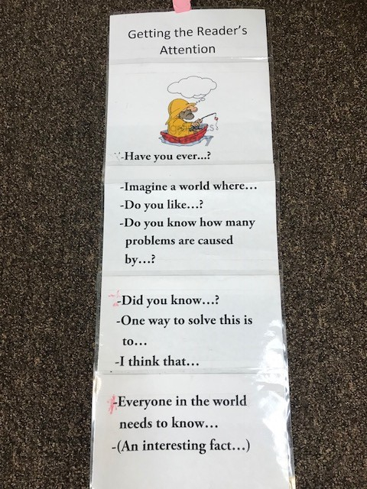

**Writing:** To help students adjust to the new classroom, students wrote letters from the perspective of different supplies. After reading *The Day the Crayons Quit,* they had to choose a supply they would like to represent and write a letter to other classmates to tell them how they should be treated. Student work will be posted in the classroom soon! We also launched our writers workshop time. Students decorated their notebooks, brainstormed the many different intentions of writers, and began writing about a person who is important to them. Over the next few weeks, students will be working on focusing on a small moment using the mentor text *Fireflies!* by Julie Brinckloe.

**Spelling/Word Work:** We began our ‘Make a Word’ spelling practice. This week’s focus is on the spelling patterns -ake, -ike, -ane, and -ine. Students have a limited amount of letters they can use to create as many different words that follow that spelling pattern. If you would like a copy, you can find the masker in the resource bucket. I also created a high frequency word wall. I will be adding words throughout the year for students to focus on. When looking over work with a student, I remind them to look over the list and check their work to make corrections.

**Math:** Students began learning routines and procedures for our math time. We engaged in math talks, learned how to use whiteboards to show mathematical thinking, played a rounding card game, created ST Math passwords, and worked on lessons 3 and 6 in EngageNY. We will get back on track with EngageNY math lessons this week!

